Volunteers needed!!

Join us on May 2, 2007 for a breakfast to celebrate the end of the Spring Semester and let our students know we support and encourage their successful completion of finals!

Faculty and staff who are willing to help cook, serve, clean tables and greet students are needed at the Annual Spring Semester Late Night Breakfast prior to the beginning of finals. All faculty, staff and alumni are invited to join us! It will be a fun time for all and a way to show our support for our students. If you are interested in helping, please contact Housing and Residence Life by Monday, April 30, 2007. Volunteers will be needed from 9:30 p.m. to 12:00 a.m. to assist with serving food, cooking, cleaning tables, greeting and working the food and beverage stations. If you can come, even if it’s only for a portion of the time, we would love to have you! Let us know what you can do. Anyone willing to be a greeter or table chatter is welcome!

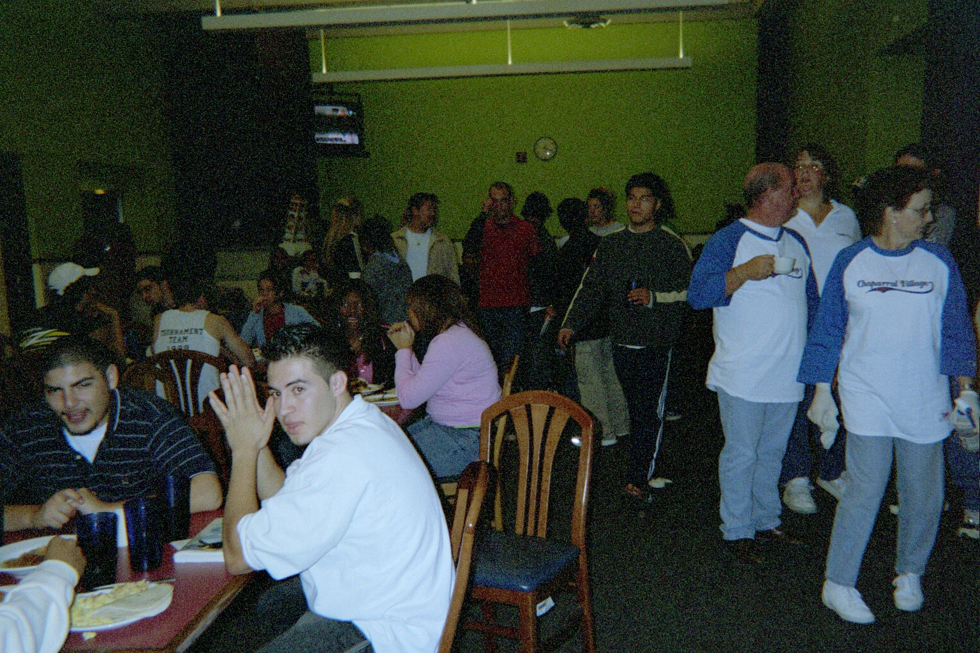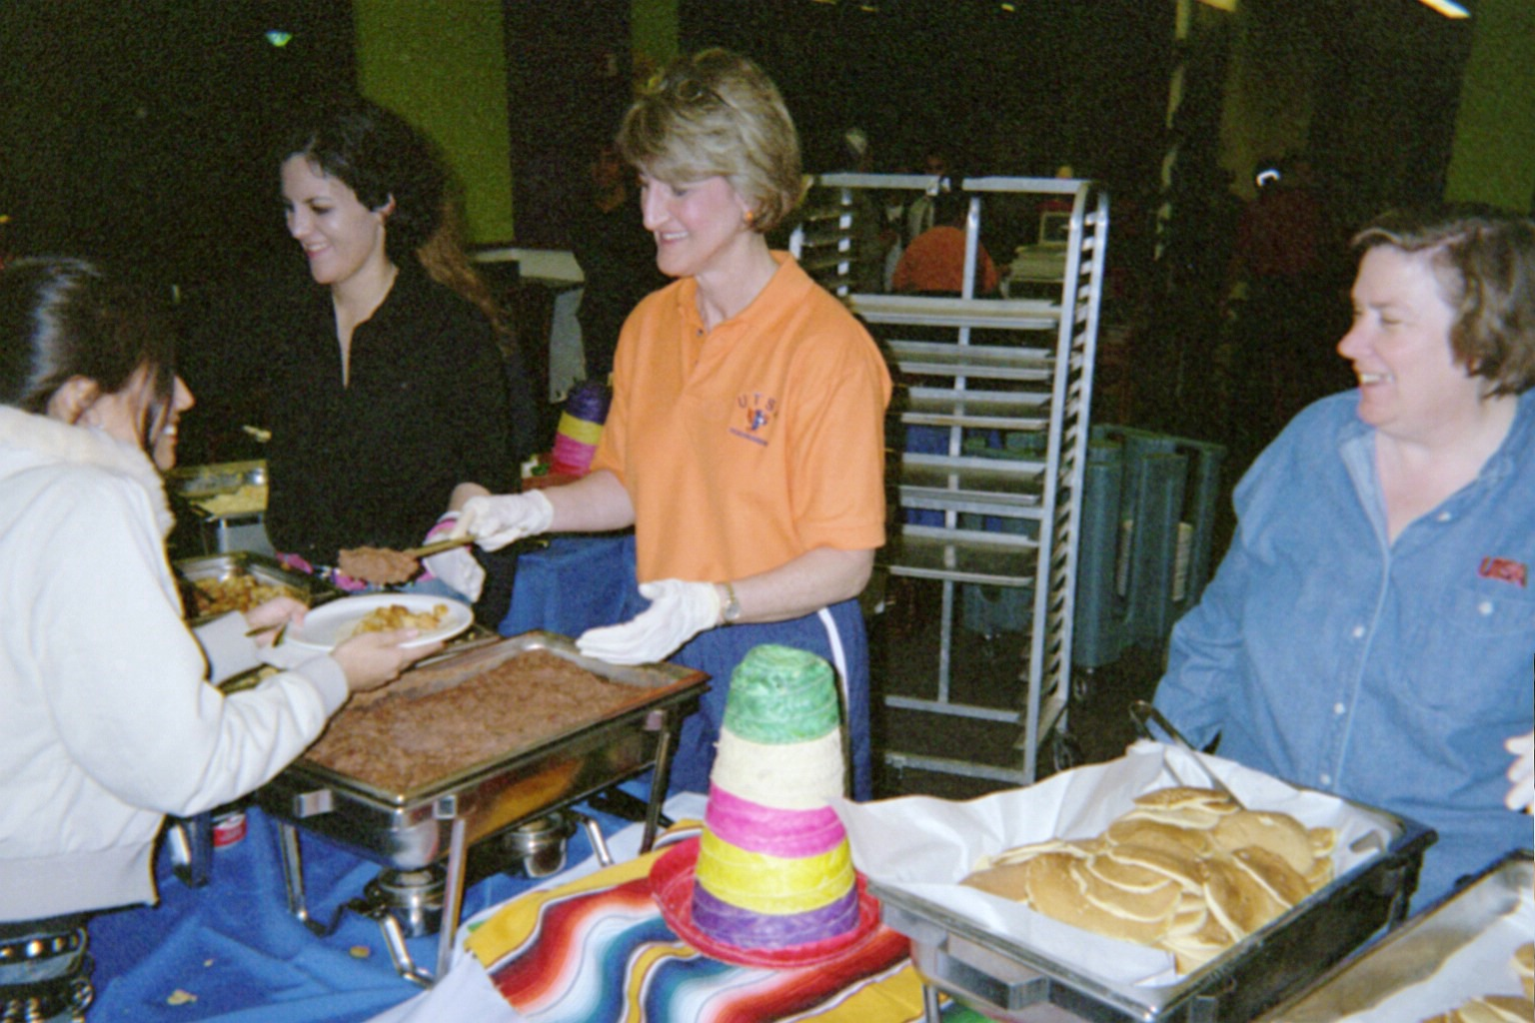

10:00 PM-12:00 AM
May 2, 2007

Please RSVP to Kim Center
kim.ellickscenter@utsa.edu or (210) 458-6200

