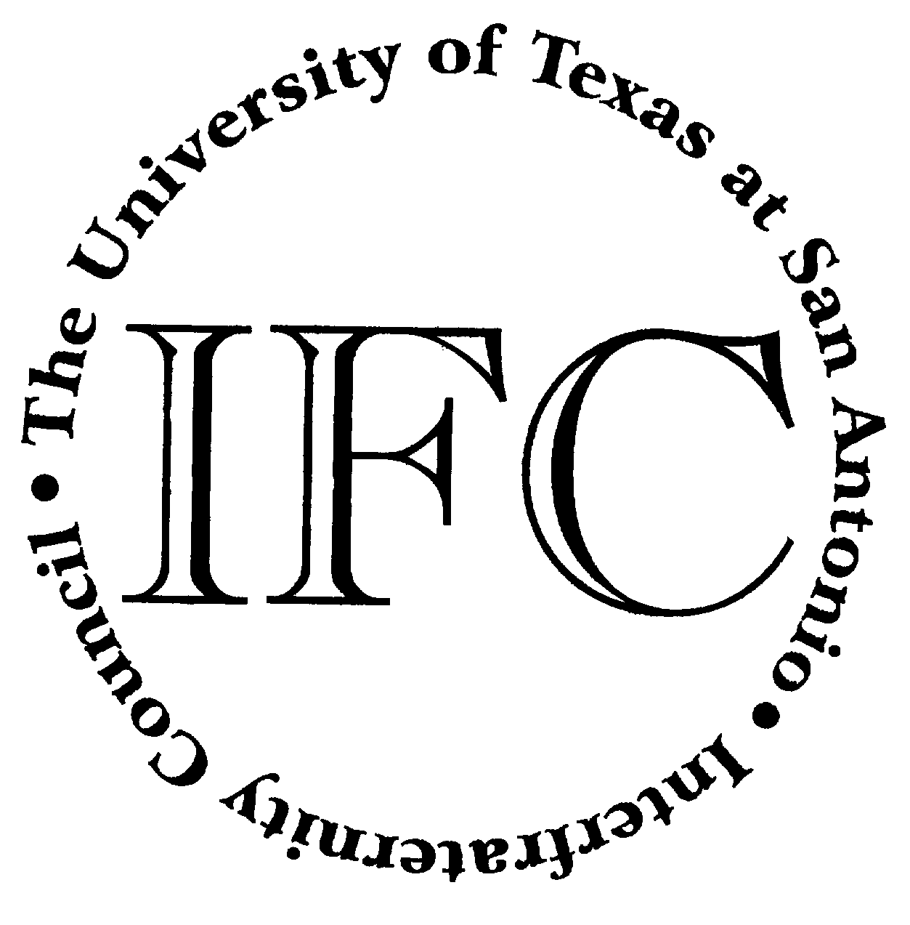
Student Activities Events For The Week Beginning April 9th

April 2nd – 27th
Fortune Cookie Contest
Learn the history of the Fortune Cookie,
Guess Correct # and win all the cookies!
Students Only Please
Durango Bldg. - Information Desk
All Day
April 9th – 13th
Ping Pong Tournament
Sign-up at DB Information Desk
DT Campus
Durango Bldg. – Student Activities Center
All Day

Wednesday, April 11, 2007
Advisor Training
1604 Campus
University Center – Hawthorne Room
4pm

Asian Tea Party
An Asian Pacific Islander Heritage Month Event
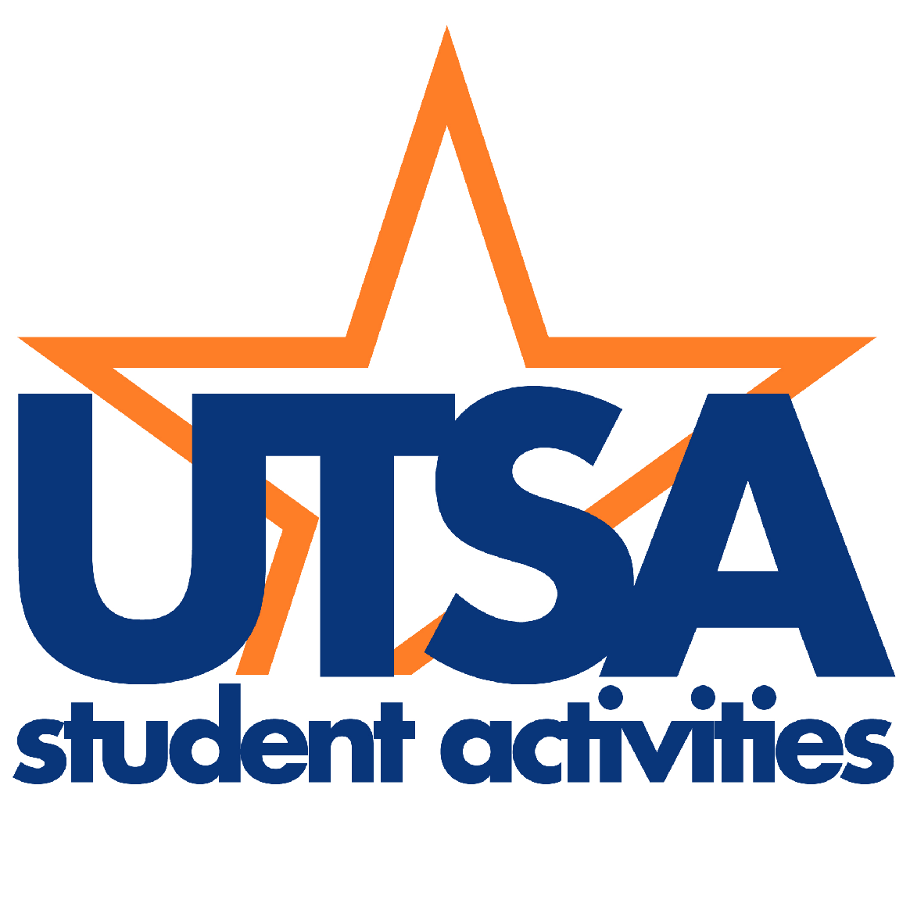
1604 Campus
University Center- Laurel Room
5pm

Thursday, April 12, 2007
Advisor Training
1604 Campus
University Center – Anaqua Room
12 noon

Friday, April 13, 2007
Honor Gala
Awards Ceremony & Dinner to Honor Those Outstanding
Faculty, Staff, and Honor Student Organizations
1604 Campus
University Center – Laurel Room
6pm
By Invitation Only


Saturday, April 14th
United to Serve
Volunteer to make a difference!
Various Locations Across San Antonio
All Day – Various Shifts
To Register go to:
http://www.utsa.edu/sa/vs

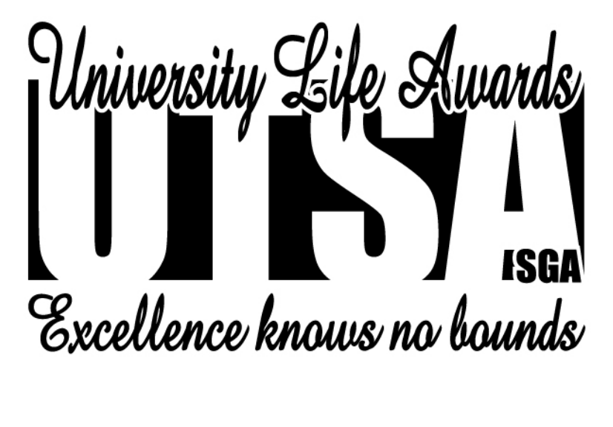
April is Asian Pacific Islander Heritage Month

